Advance selection or filtering using where

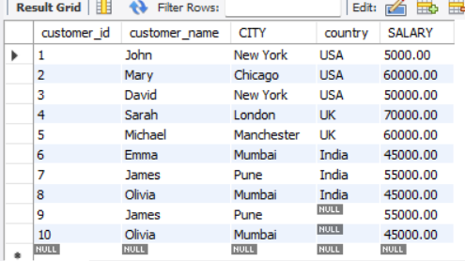

Comparison Operators:
= | Equal to
<> | Not equal to
!= | Not equal to
< | Less than
> | Greater than
<= | Less than or equal to
>= | Greater than or equal to
Comparison
SELECT * FROM Customers
WHERE Country='Mexico';

SELECT * FROM cust2
WHERE salary = 60000;

Logical Operators:
AND | Logical AND
OR | Logical OR
NOT | Logical NOT
SELECT * FROM Customers
WHERE Country='Germany' AND City = 'Berlin';

SELECT * FROM Customers
WHERE Country='Germany' AND (City='Berlin' OR City= 'Munchen');

Membership Operators:
IN | Checks if a value exists in a set of values
NOT IN | Checks if a value does not exist in a set of values
SELECT * FROM CUST2
WHERE CITY IN ('London','Mumbai');

Between Operator:
BETWEEN | Checks if a value lies within a specified range
Not BETWEEN | Checks if a value lies within a specified range
SELECT * FROM CUST2
where salary between 50000 AND 60000;

SELECT * FROM Products
WHERE Price BETWEEN 10 AND 20;

SELECT * FROM Products
WHERE Price NOT BETWEEN 10 AND 20;

LIKE Operator(WILDCARD):
LIKE | Matches patterns in strings using wildcard characters % and _
Starting with "ber":
SELECT * FROM Customers
WHERE City LIKE 'ber%';

City containing the pattern "es"
SELECT * FROM Customers
WHERE City LIKE '%es%'

STARTING WITH 'ber%'
ENDING WITH '%ber '
CONTAINS '%O% '

IS NULL Operator:
IS NULL | Checks if a value is NULL
IS NOT NULL | Checks if a value is not NULL
SELECT * FROM cust2
WHERE country IS NULL;

SELECT * FROM cust2
WHERE country IS NOT NULL;

NULL
SELECT * FROM Customers
WHERE Address IS NULL;

SELECT * FROM Customers
WHERE Address IS NOT NULL;

LIMIT
SELECT Salary FROM Customers
WHERE Country='Germany'
LIMIT 3;

